Based on your project database, you will continue to create TQL code for the following problems.  Submit a screenshot of both the code and it being tested.

7) Create a stored procedure, called sp_Employees, that returns a select statement that shows all the employees working for the company. This procedure should have the emp_full_name and employee_id columns in your select.

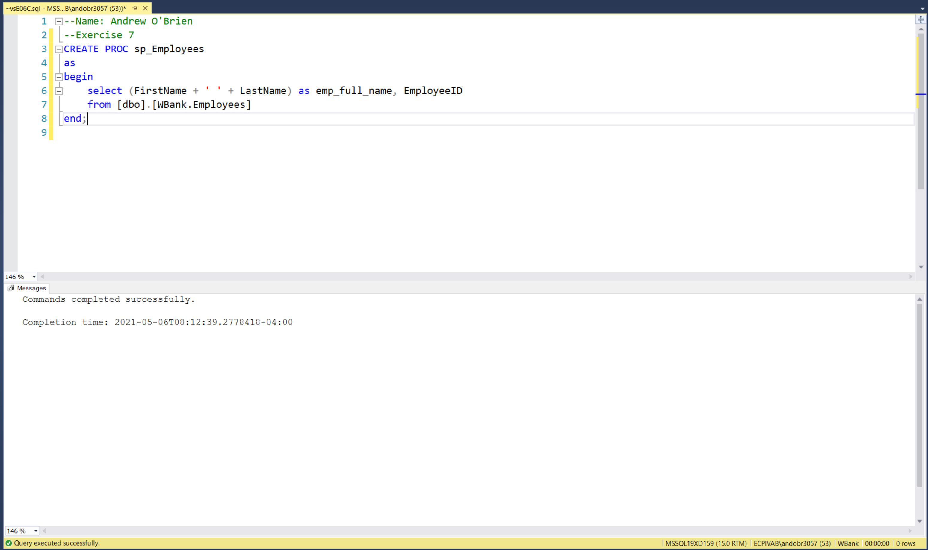

8) Create a stored procedure, called sp_Locations, that returns a select statement that shows all the locations that this bank has. This procedure should have the location_id***,*** and location_code columns in your select***.***

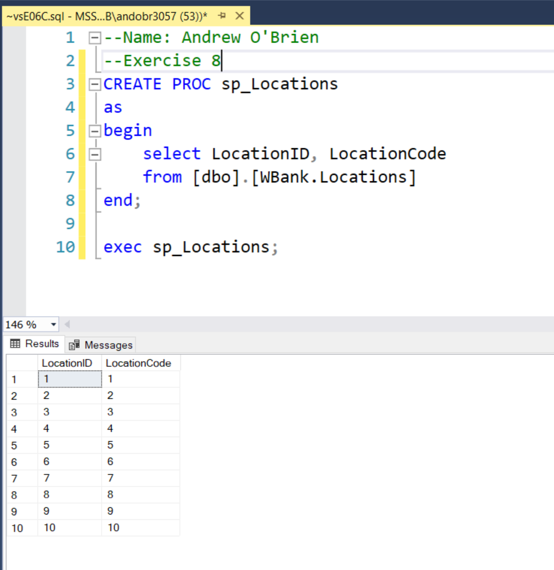

9) Create an Insert procedure, called sp_Insert_Deposit, for adding a deposit for a customer into the database. In your procedure ensure that the locationId, employeeid, and customerID are valid values.  If they are not, throw an error.  Also, ensure that the deposit date is a valid date.

If all the validation passes, insert the data into your deposits table and return the depositID as an out parameter.

Parameters to your procedure should be***:*** locationID, employeeID, customerID, and return a depositID.

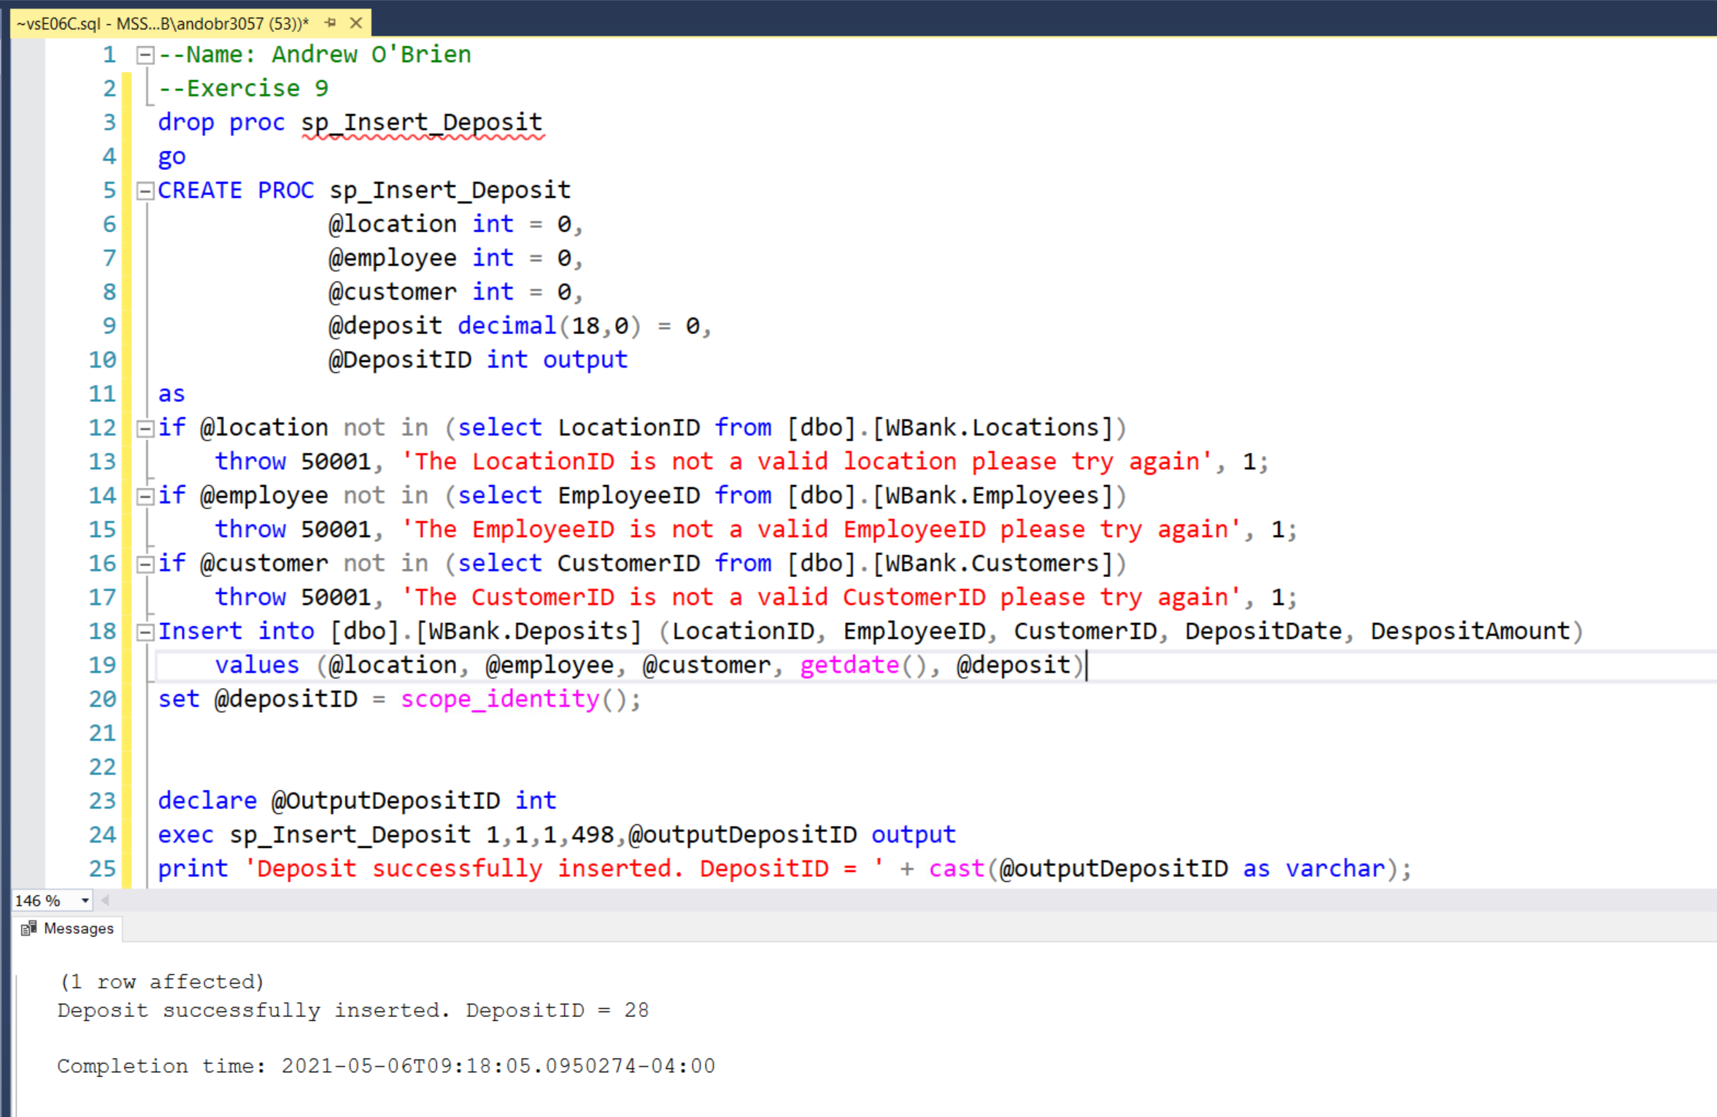

10) Create an Insert procedure, called sp_WithDraw, for adding a withdrawal for a customer into the database. In your procedure ensure that the locationId, employeeid, and customerID are valid values.  If they are not, throw an error.  Also, ensure that the withdrawal date is a valid date.  Finally, ensure that the customer has enough money to withdraw and  if they don't throw an error.

If all the validation passes, insert the data into your withdrawal table and return the withdrawalID as an out parameter.

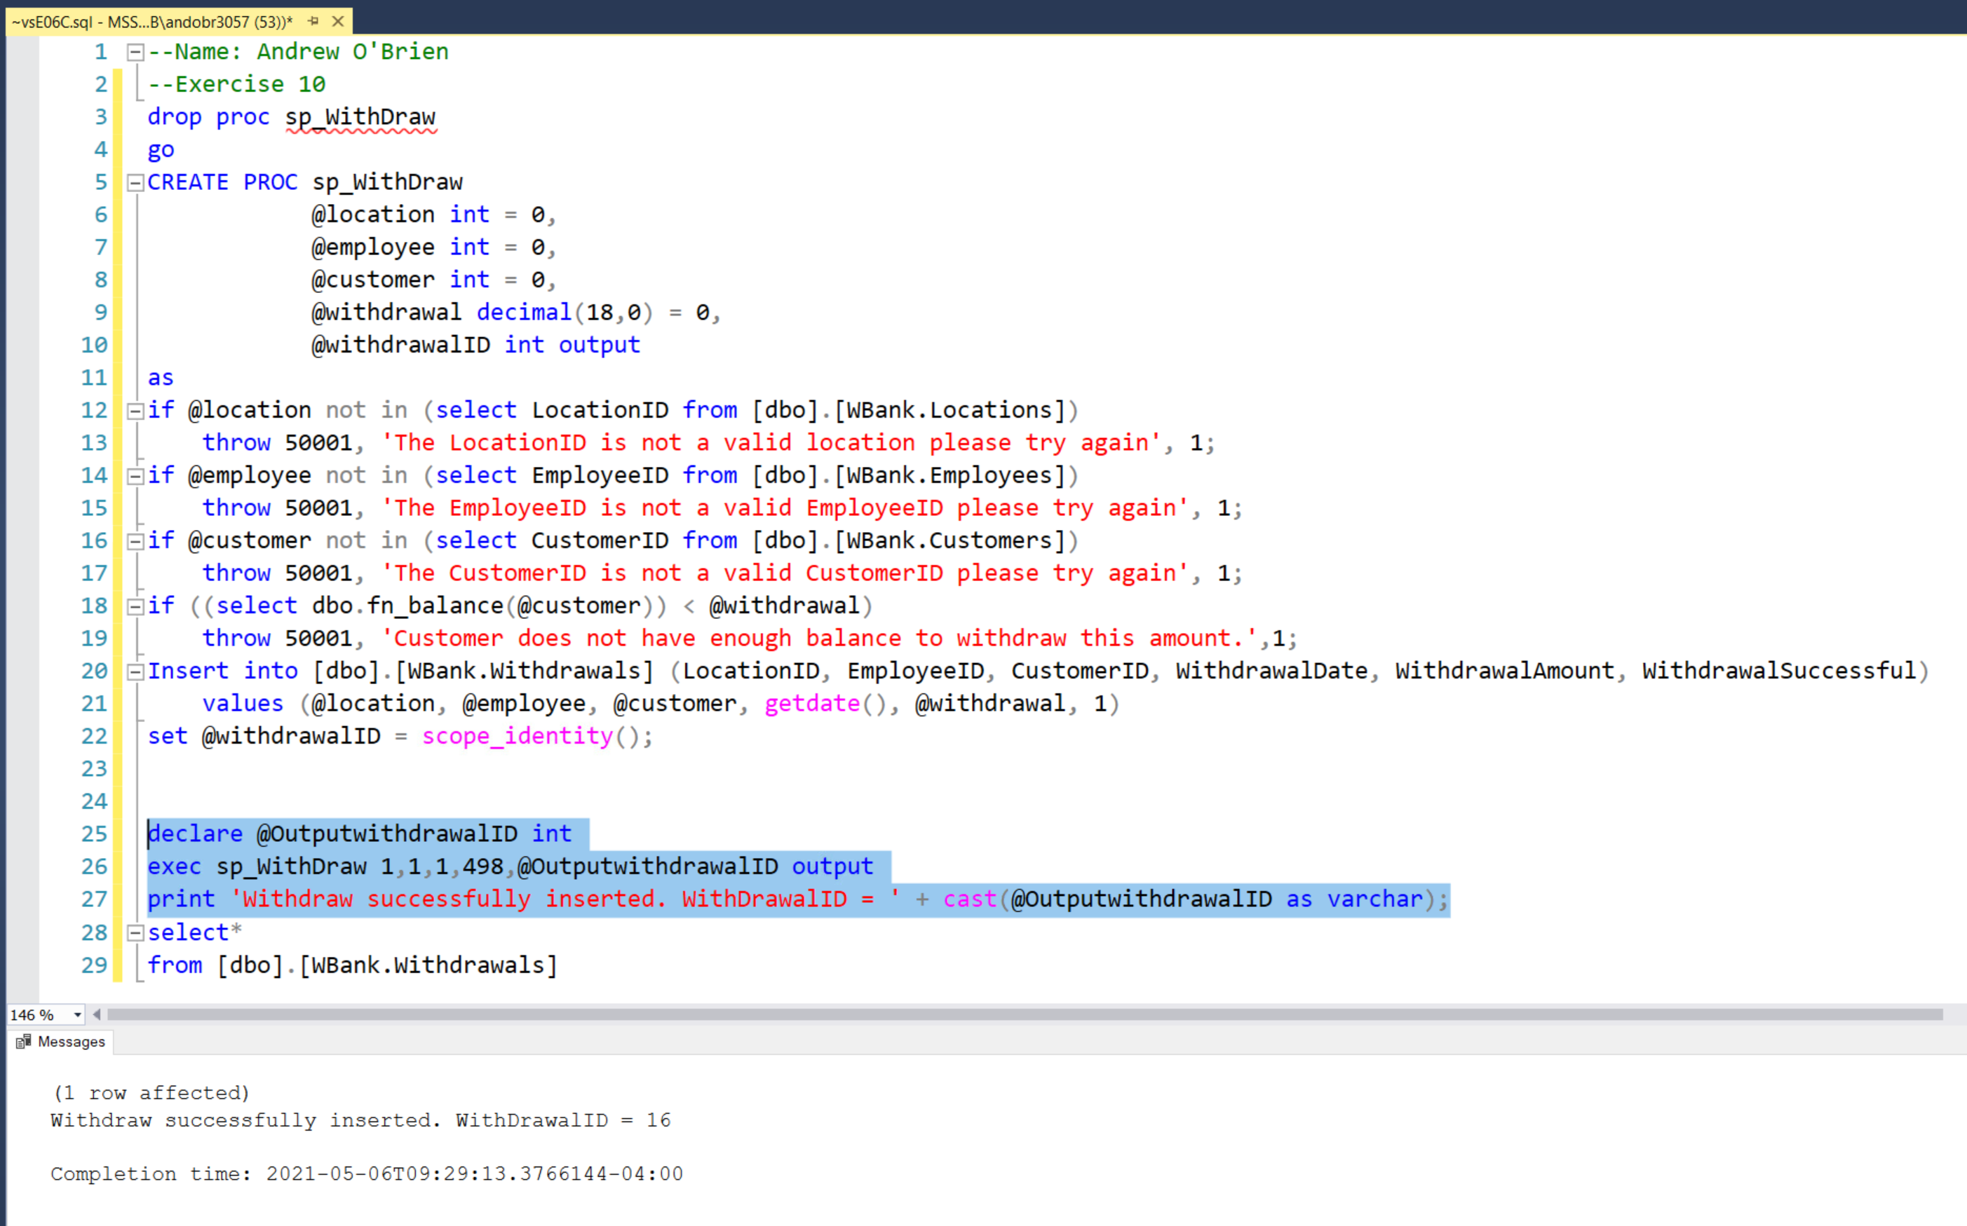

11) Create a SQL Server role called CIS435L_Project. Grant the role db_datareader to CIS435_Project.  In addition, grant the ability to execute all stored procedures created for this project to this role.

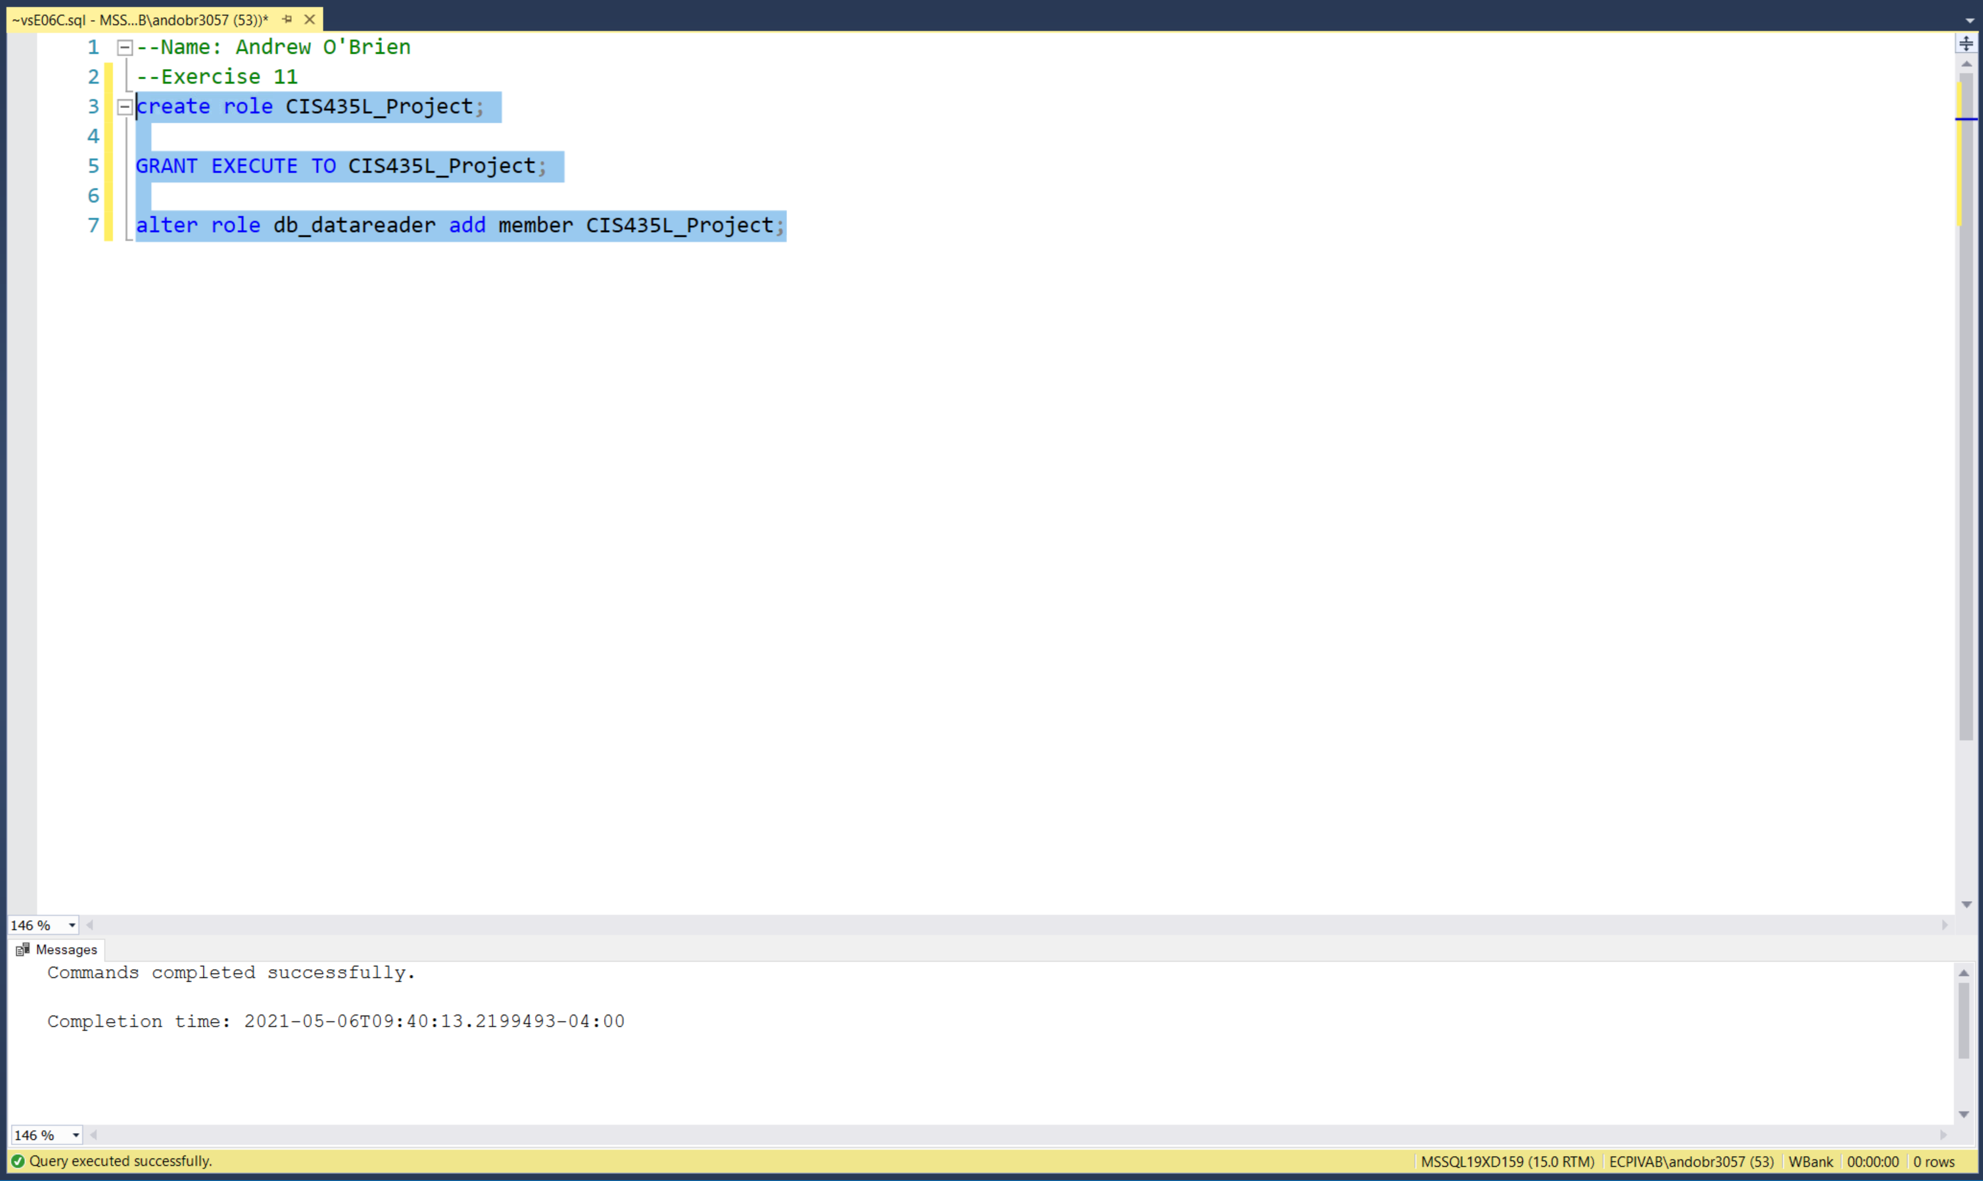

12) Create a user called CIS435L_User1.  Grant this user the CIS435L_Project role.  Prove that you can call one of the stored procedures or functions created for this project using this CIS435L_User1 user.

Had a CIS435L_User1 already in the system so we named it CIS435L_User2

